**Supplementary figures.**

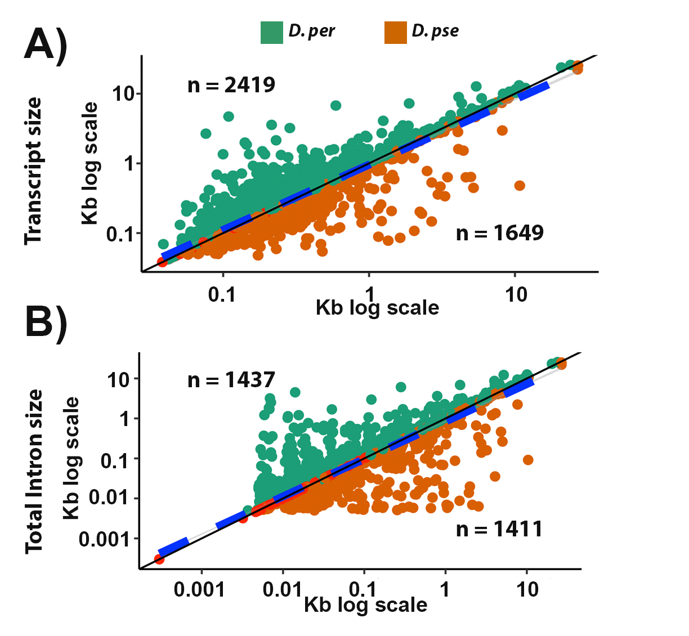

**Figure S1.** Correlation plots for transcript size (A) and intron size (B) between *D. pseudoobscura* and *D. persimilis* for the 4,613 orthologous genes with the same aminoacid length. ‘n’ depicts the number of genes with larger transcript size (A) or larger intron size (B) for each species (above or below the curve). Black solid line represents the 1:1 expectation between species; blue dashed line depicts the implemented LM: R2 = 0.8694; Intercept = 0.2358; Slope = 0.9363 (A) and R2 = 0.8756; Intercept = 0.1736; Slope = 0.9372 (B).

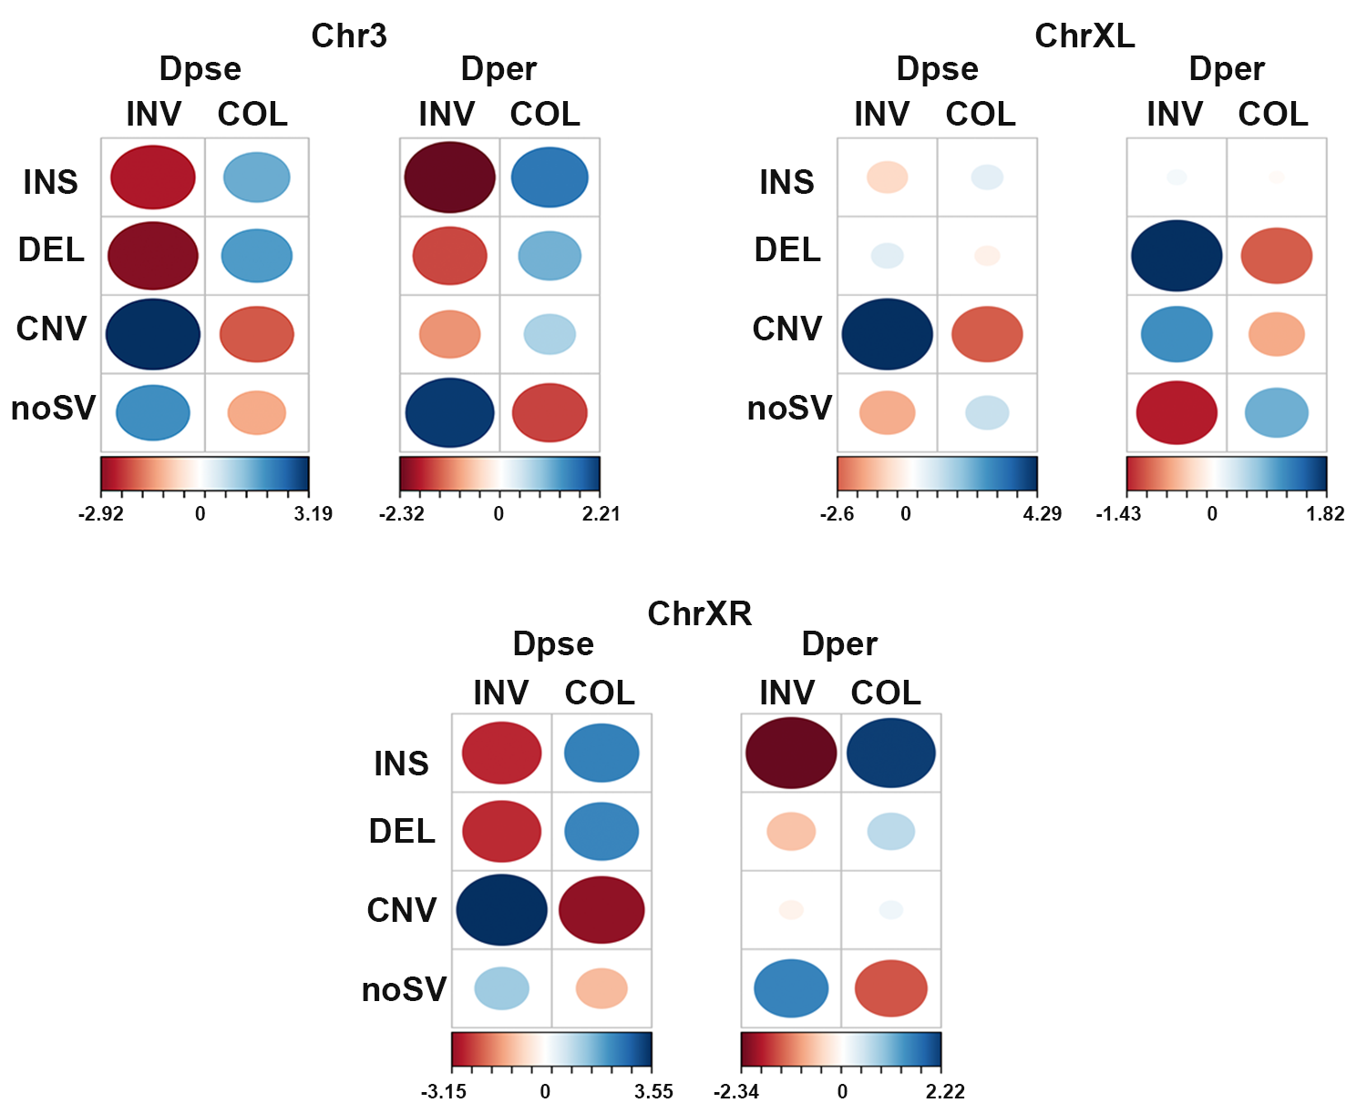

**Figure S2**. Correspondence analysis showing the association between genes (including the 10kb upstream region) and SVs, for chromosomes 3, XL and XR. Circle sizes depict the number of genes, and color depicts correlation values (bottom of contingency table). INS: insertions; DEL: deletions; CNV: copy-number variants; noSV: genes not associated with SVs.

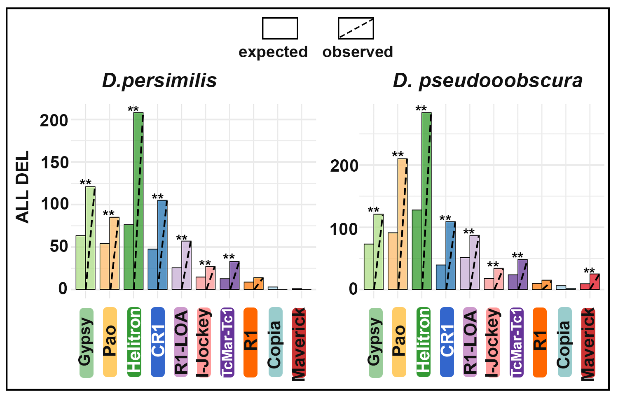

**Figure S3**. Permutation analysis of DEL overlapping TE annotations; ** p < 0.01 significant difference between observed and expected counts.

**Figure S4.** Expression levels of the 10 most abundant TE families in both *D. pseudoobscura* and *D. persimilis* (x-axis). Colors depict four developmental stages and average read counts are represented in log scale (y-axis). Up graph show read counts using *D. pseudoobscura* genome as a reference and bottom graph is the reciprocal analysis using *D. persimilis* genome as a reference.

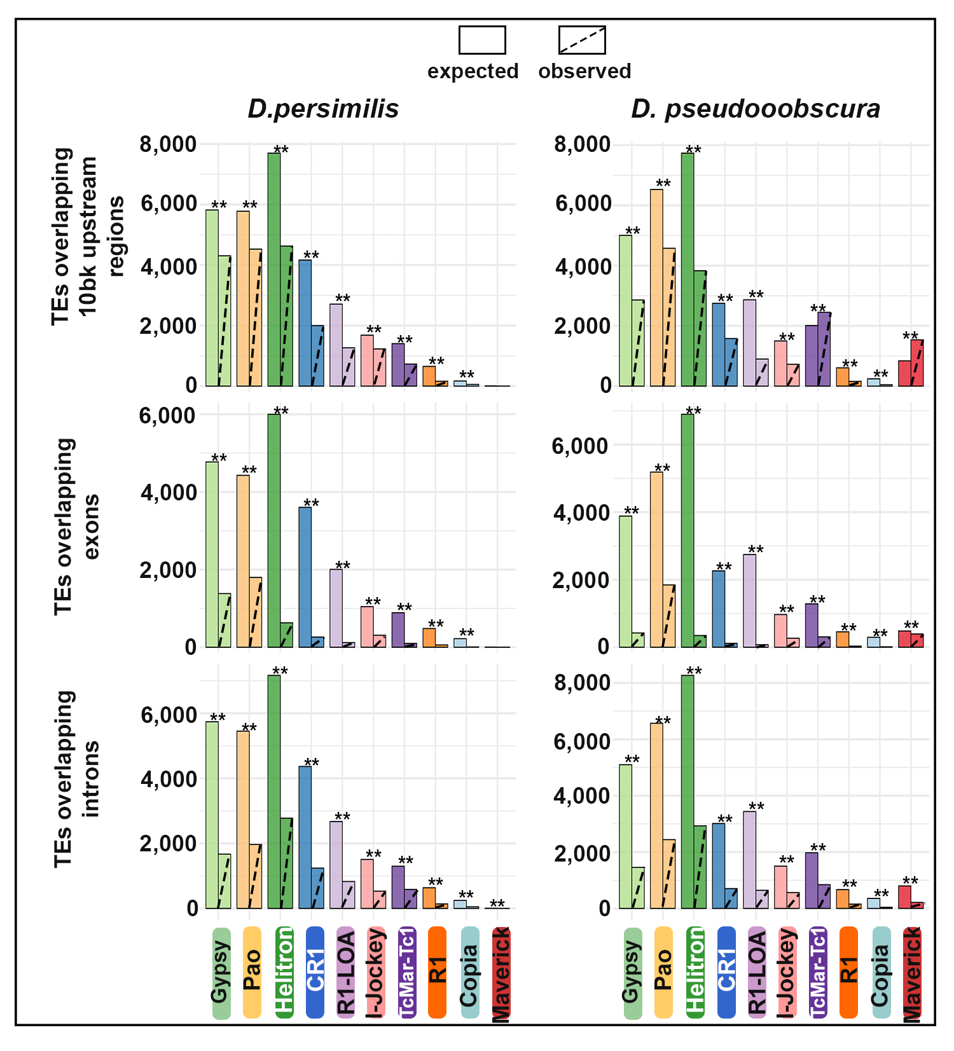

**Figure S5.** Permutation analysis of TEs overlapping annotated gene regions; ** p < 0.01 significant difference between observed and expected counts.

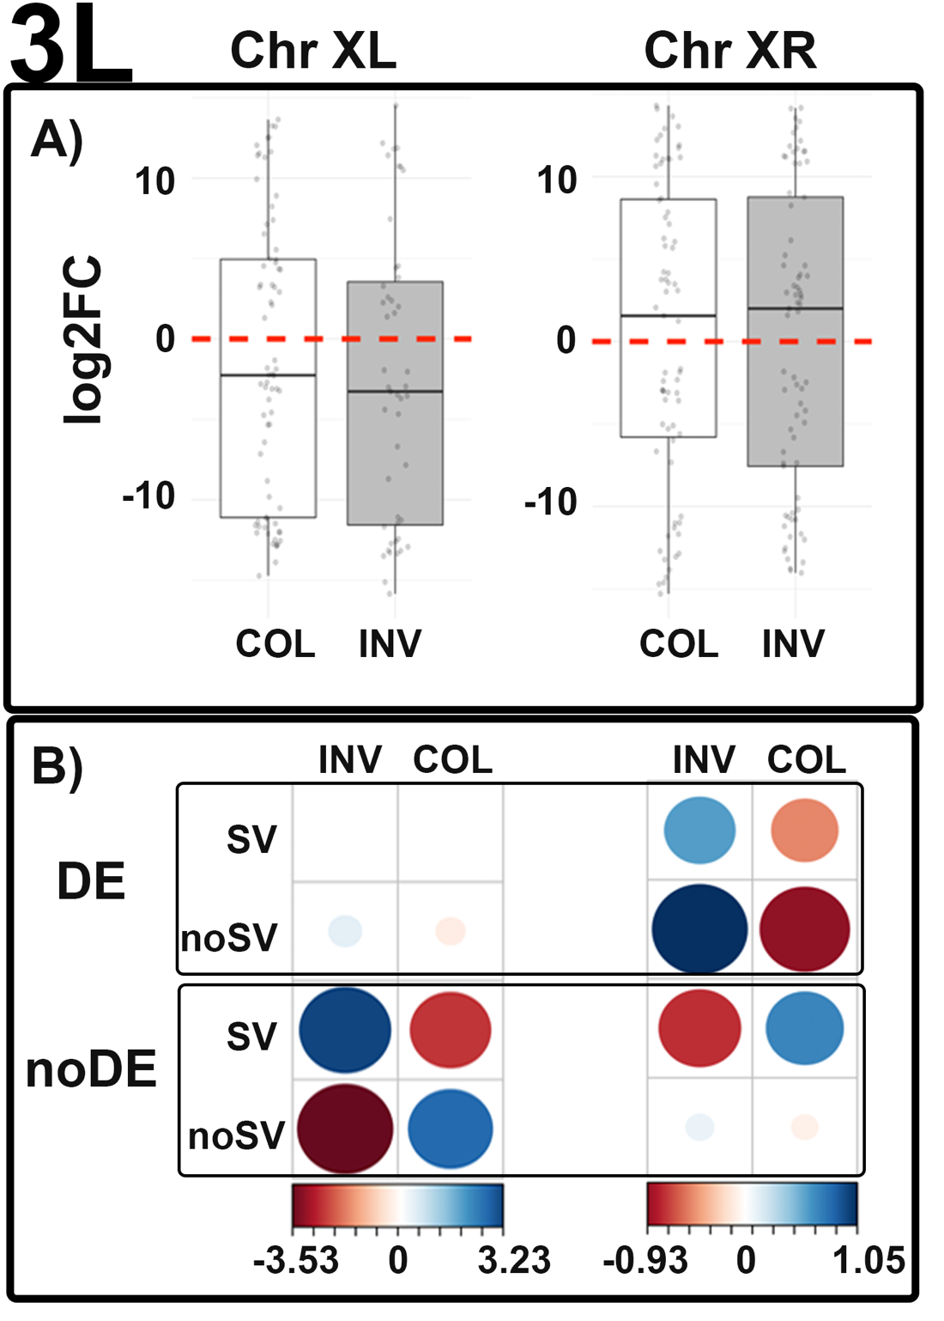  
**Figure S6.** Gene expression and its association with SVs for chromosomes with inversion differences between *D. pseudoobscura* and *D. persimilis* for the 3L developmental stage. A) Log2 fold change values for differentially expressed genes comparing the co-linear and inverted regions; > 0 higher expression in *D. pseudoobscura*; < 0 higher expression in *D. persimilis*. B) Correspondence analysis showing the association of genes differentially expressed (DE) or not (noDE) with the presence of absence of SVs in the 3L stage; circle sizes depict number of genes, and color depicts correlation values (contribution of the overall Chi-square statistic).

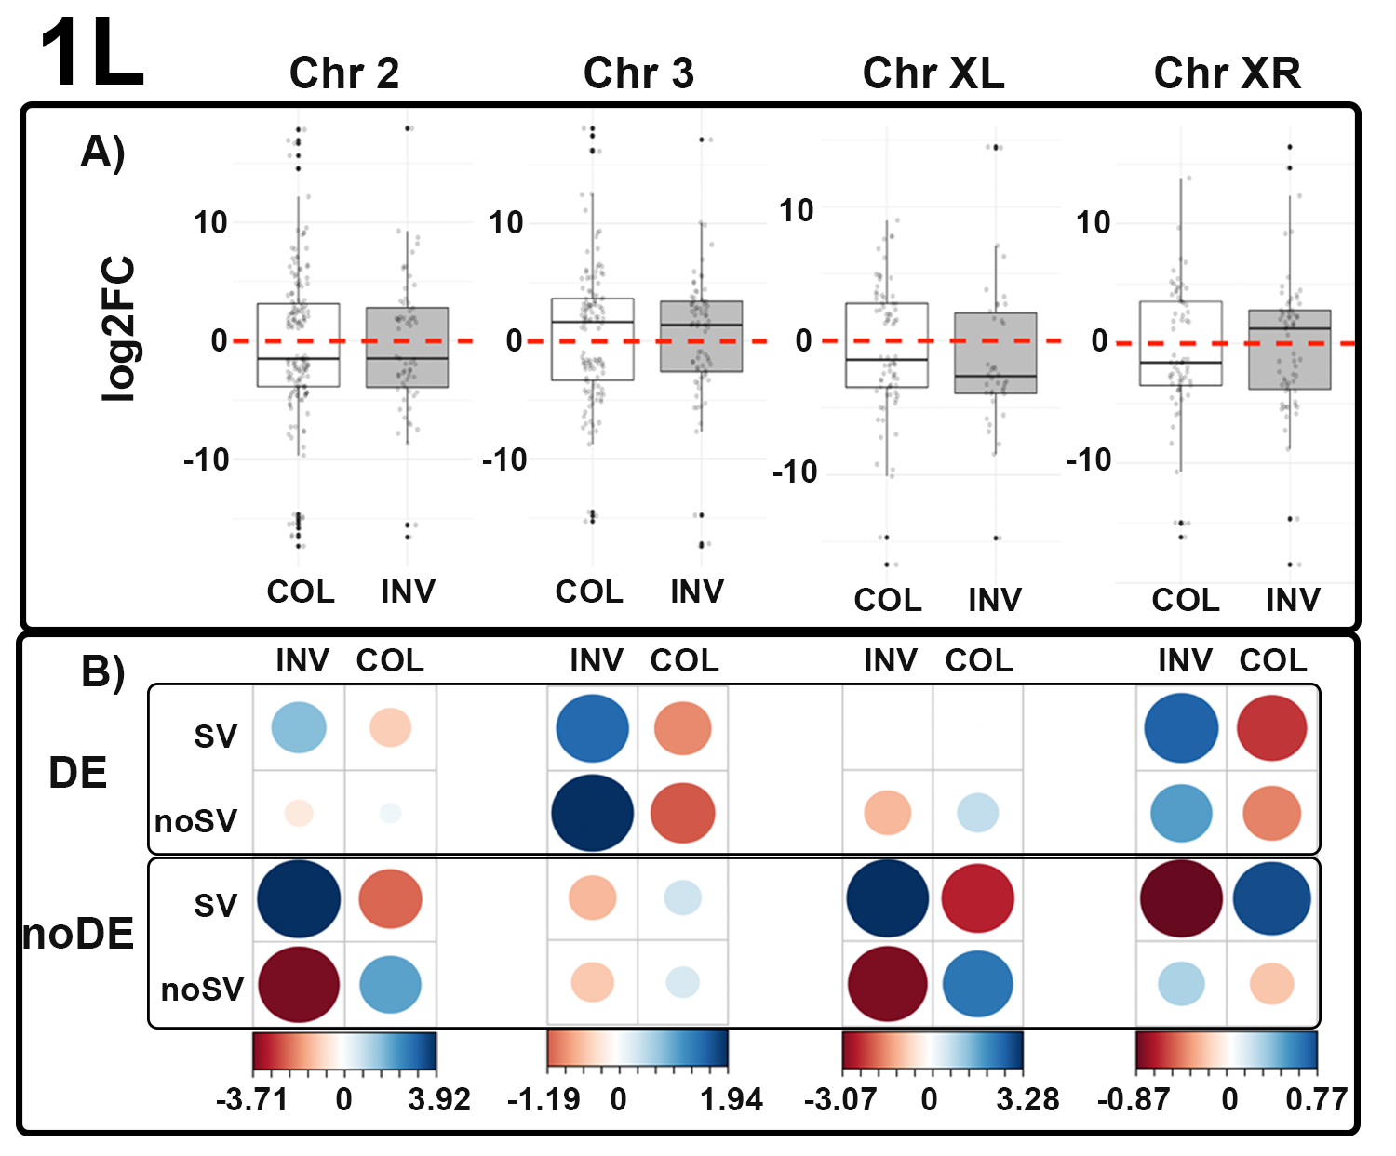

**Figure S7.** Gene expression and its association with SVs for chromosomes with inversion differences between *D. pseudoobscura* and *D. persimilis* for the 1L developmental stage. A) Log2 fold change values for differentially expressed genes comparing the co-linear and inverted regions; > 0 higher expression in *D. pseudoobscura*; < 0 higher expression in *D. persimilis*. B) Correspondence analysis showing the association of genes differentially expressed (DE) or not (noDE) with the presence of absence of SVs in the 1L stage; circle sizes depict number of genes, and color depicts correlation values (contribution of the overall Chi-square statistic).

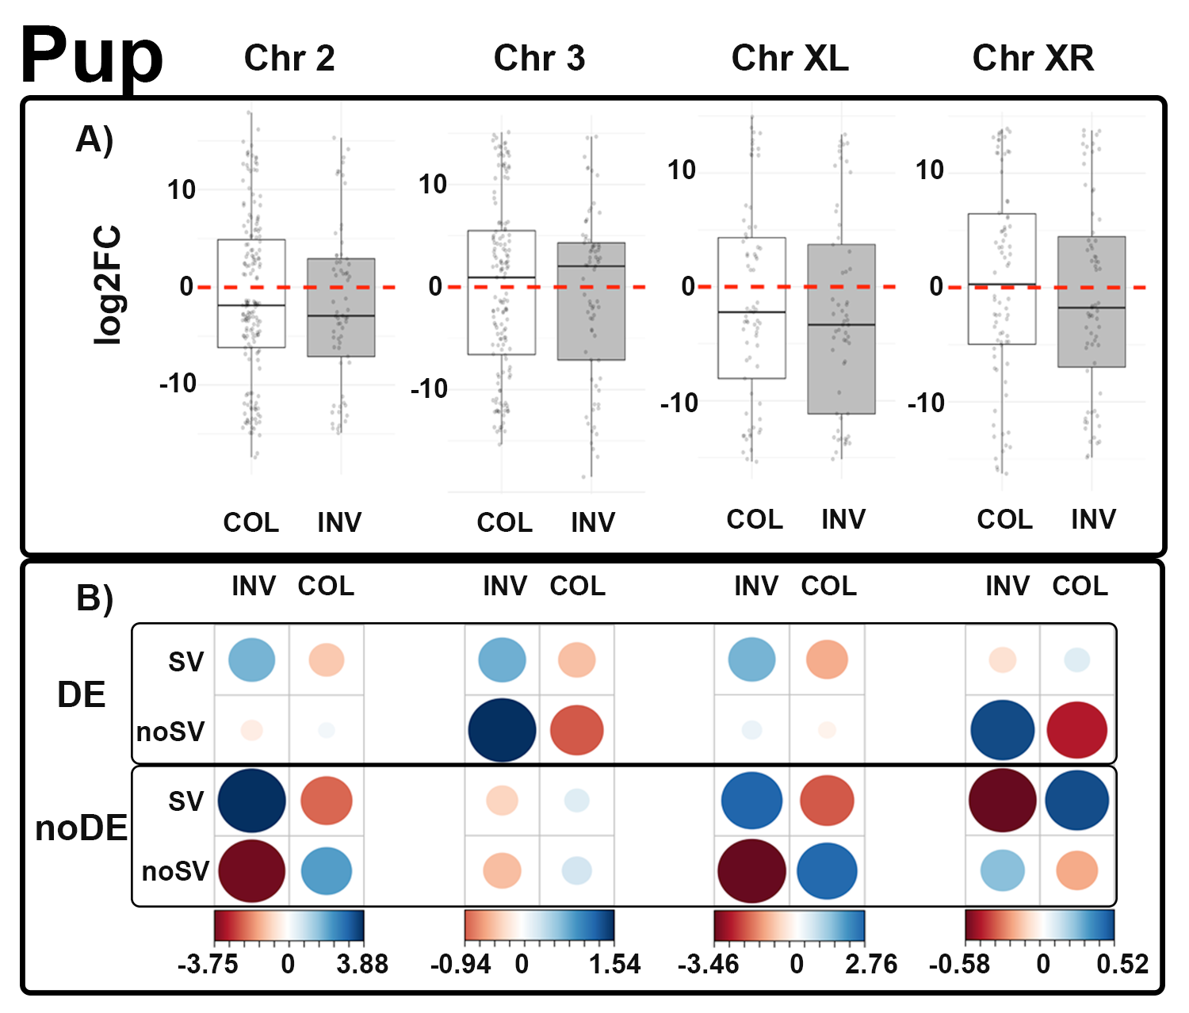

**Figure S8.** Gene expression and its association with SVs for chromosomes with inversion differences between *D. pseudoobscura* and *D. persimilis* for the Pup developmental stage. A) Log2 fold change values for differentially expressed genes comparing the co-linear and inverted regions; > 0 higher expression in *D. pseudoobscura*; < 0 higher expression in *D. persimilis*. B) Correspondence analysis showing the association of genes differentially expressed (DE) or not (noDE) with the presence of absence of SVs in the Pup stage; circle sizes depict number of genes, and color depicts correlation values (contribution of the overall Chi-square statistic).

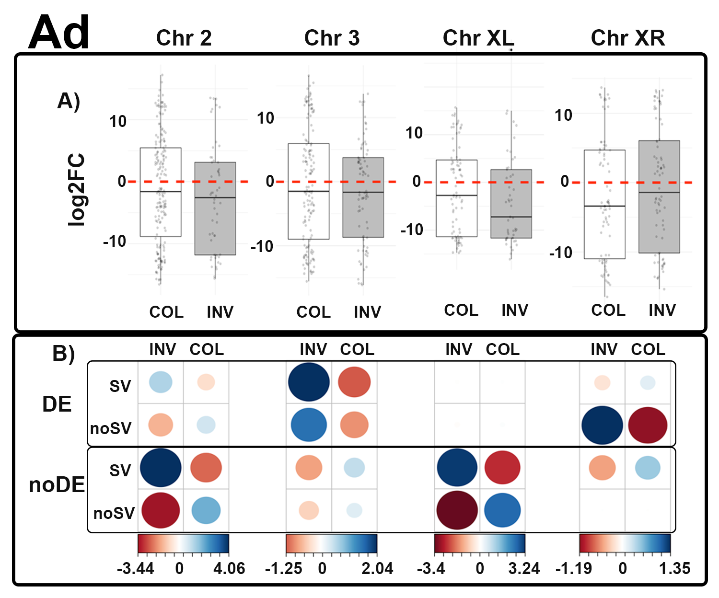

**Figure S9.** Gene expression and its association with SVs for chromosomes with inversion differences between *D. pseudoobscura* and *D. persimilis* for the Ad developmental stage. A) Log2 fold change values for differentially expressed genes comparing the co-linear and inverted regions; > 0 higher expression in *D. pseudoobscura*; < 0 higher expression in *D. persimilis*. B) Correspondence analysis showing the association of genes differentially expressed (DE) or not (noDE) with the presence of absence of SVs in the 3L stage; circle sizes depict number of genes, and color depicts correlation values (contribution of the overall Chi-square statistic).

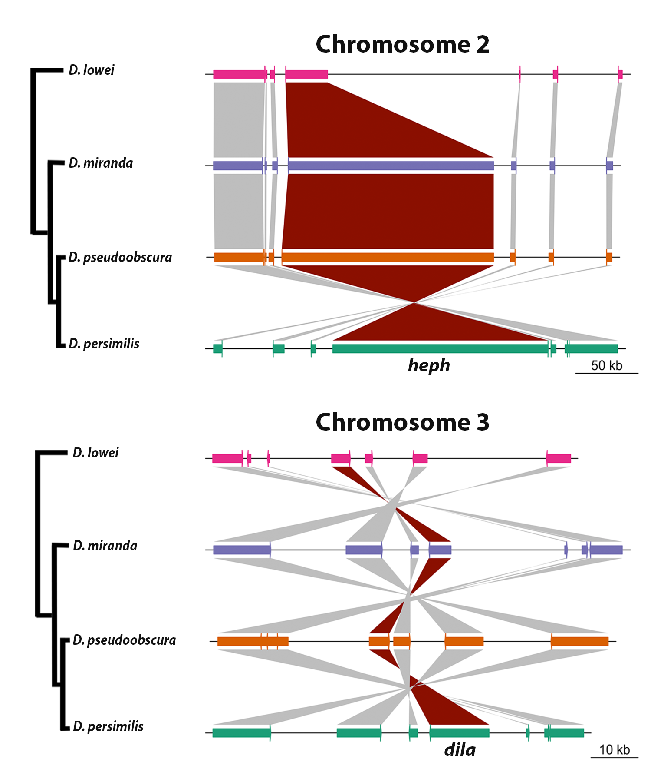

**Figure S10.** Genomic context (up) of the *heph* and *dila* (darked ribbon) genes showing conservation on the order of neighbor genes both up and downstream across the *D. pseudoobscura* subgroup.

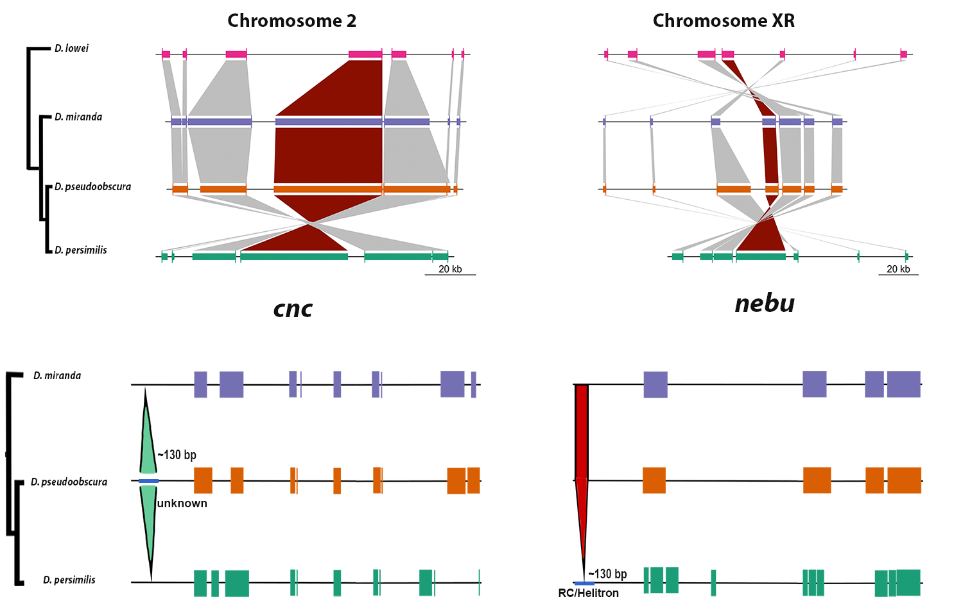

**Figure S11.** Genomic context (up) of the *cnc* and *nebu* (darked ribbon) genes showing conservation on the order of neighbor genes both up and downstream across the *D. pseudoobscura* subgroup. The bottom figures show the *cnc* and *nebu* gene models and the position of an INS occurring in *D. pseudoobscura* and a DEL occurring in *D. persimilis*, both in the 10kb-upstream region.

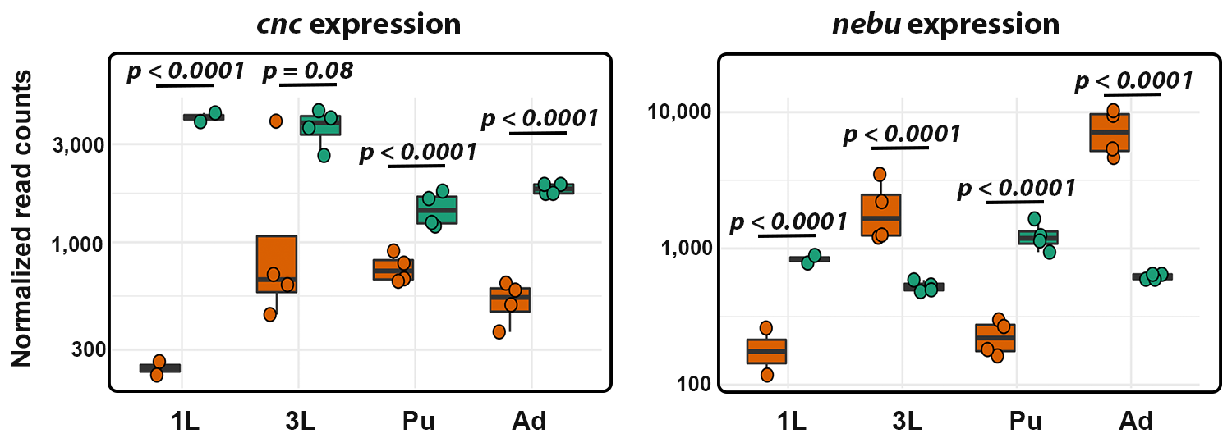

**Figure S12.** Boxplots showing the normalized read counts in log scale for *cnc* and *nebu* over four developmental stages: 1L: first instar larvae, 3L: third instar larvae, Pup: Pupae, Ad: Adult, between *D. pseudoobscura* (orange) and *D. persimilis* (green).



**Figure S13.** Dot plot for the final assemblies of *D. pseudoobscura* and *D. persimilis*. Purple dots represent co-linear blocks and light blue dots represent inversions in the corresponding chromosomes. REF(x-axis): *D. pseudoobscura*; QRY(y-axis): *D. persimilis*.



**Figure S14. dpseMCvsMV225**



**Figure S15. dperMCvsMV225**



**Figure S16. pseMC2FB**



**Figure S17. perMCvsFB**

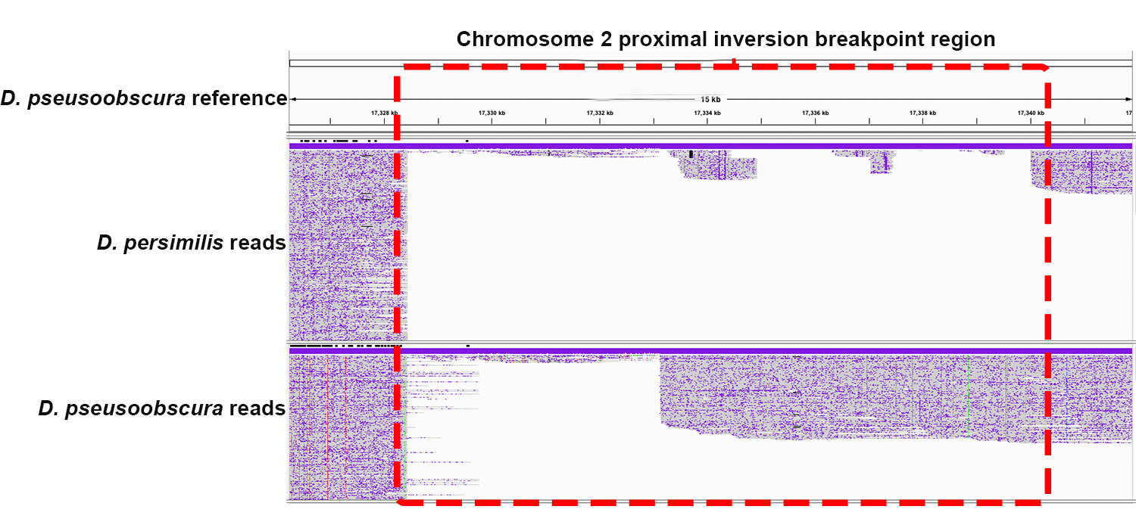

**Figure S18.**

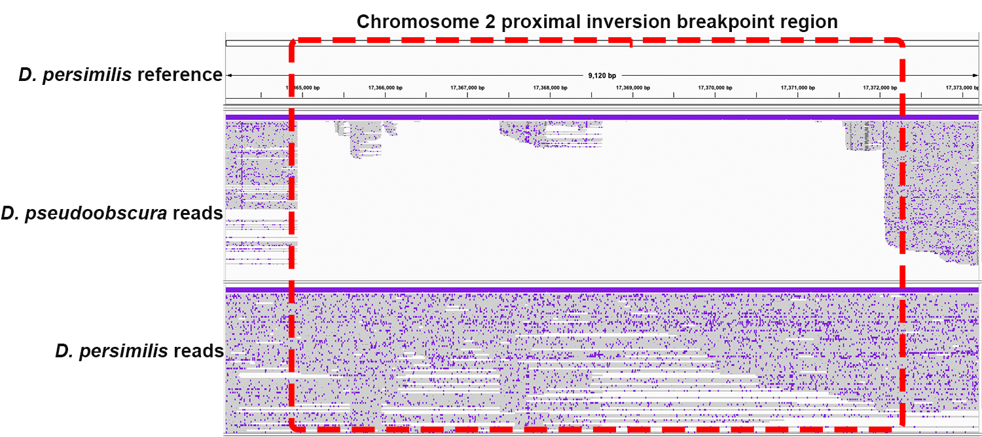

**Figure S19.**

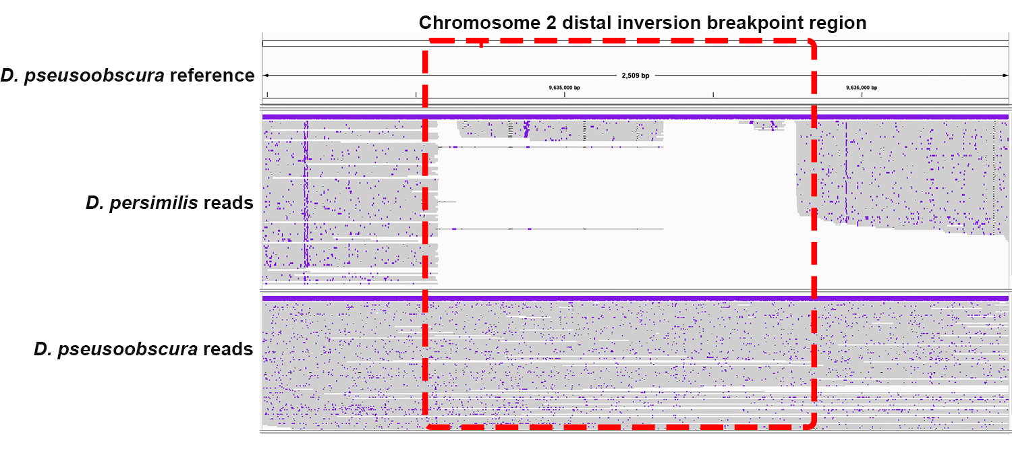

**Figure S20.**

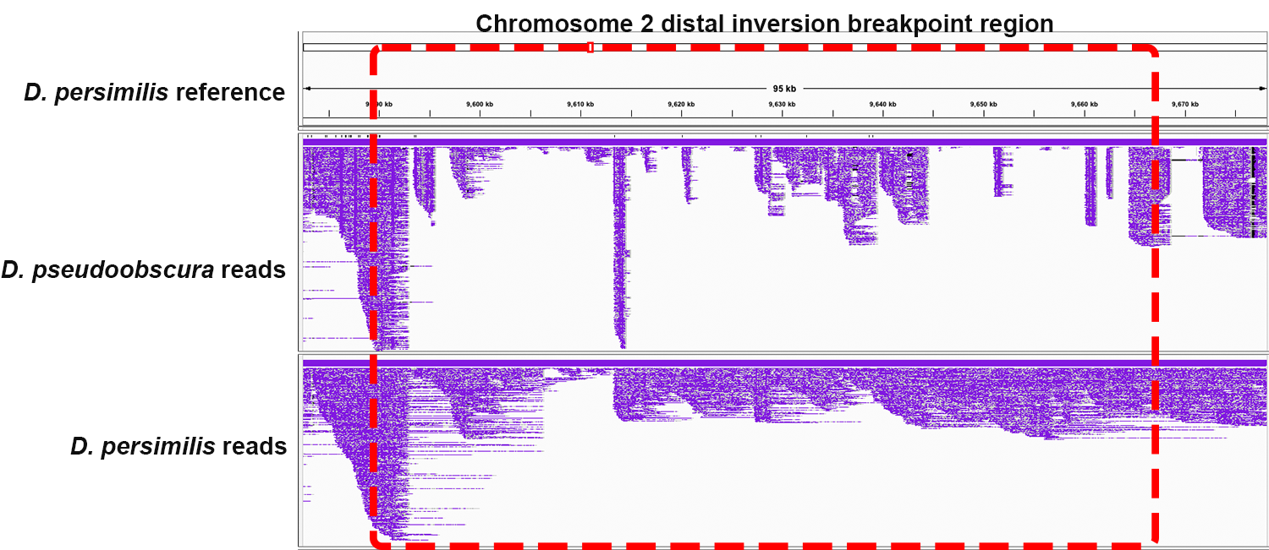

**Figure S21.**

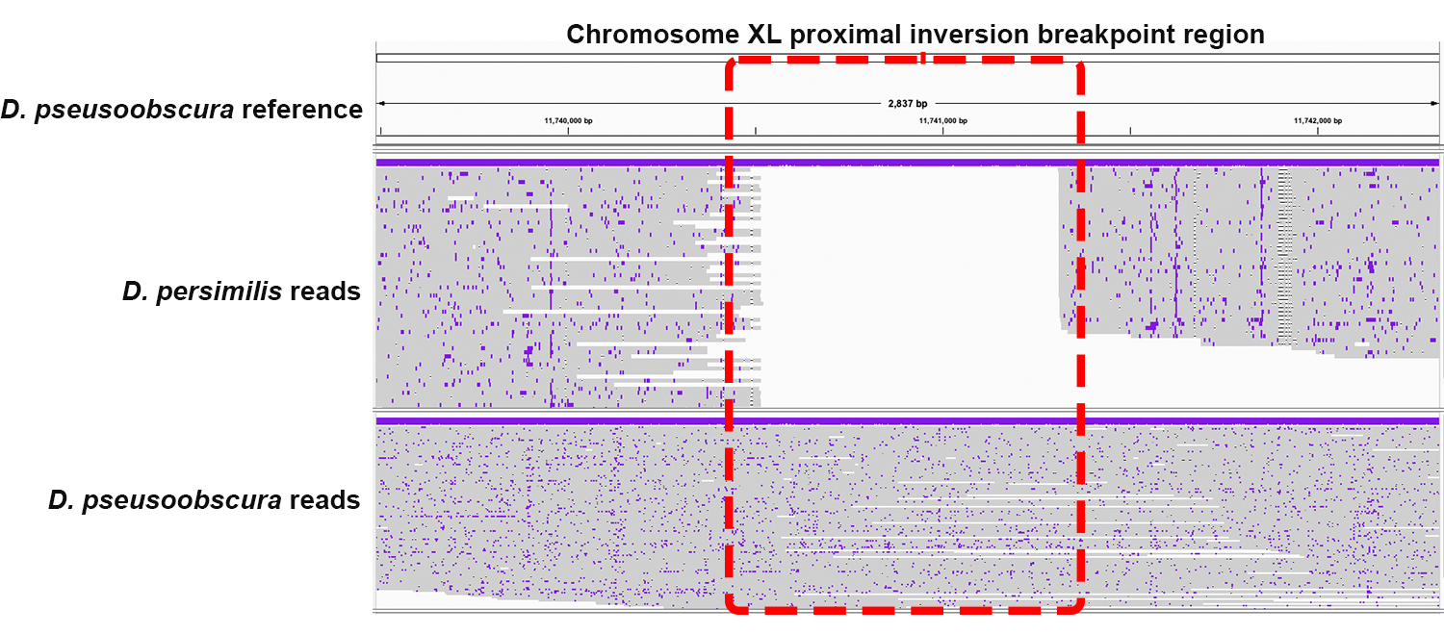

**Figure S22.**

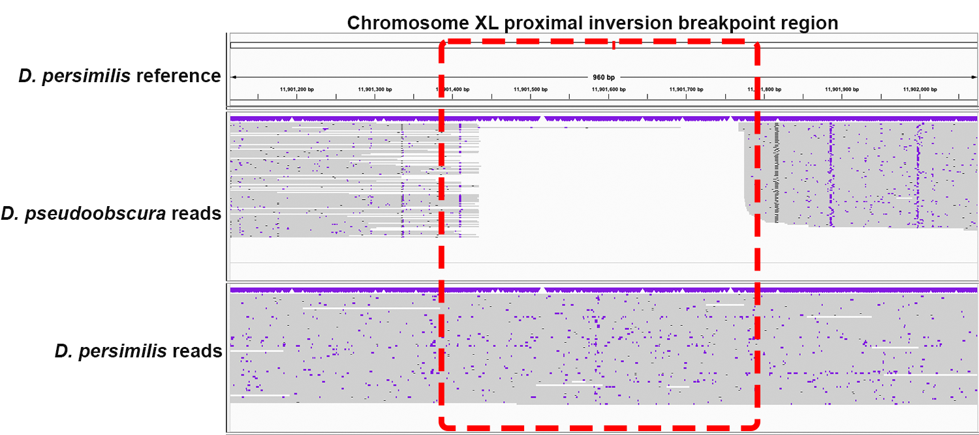

**Figure S23.**

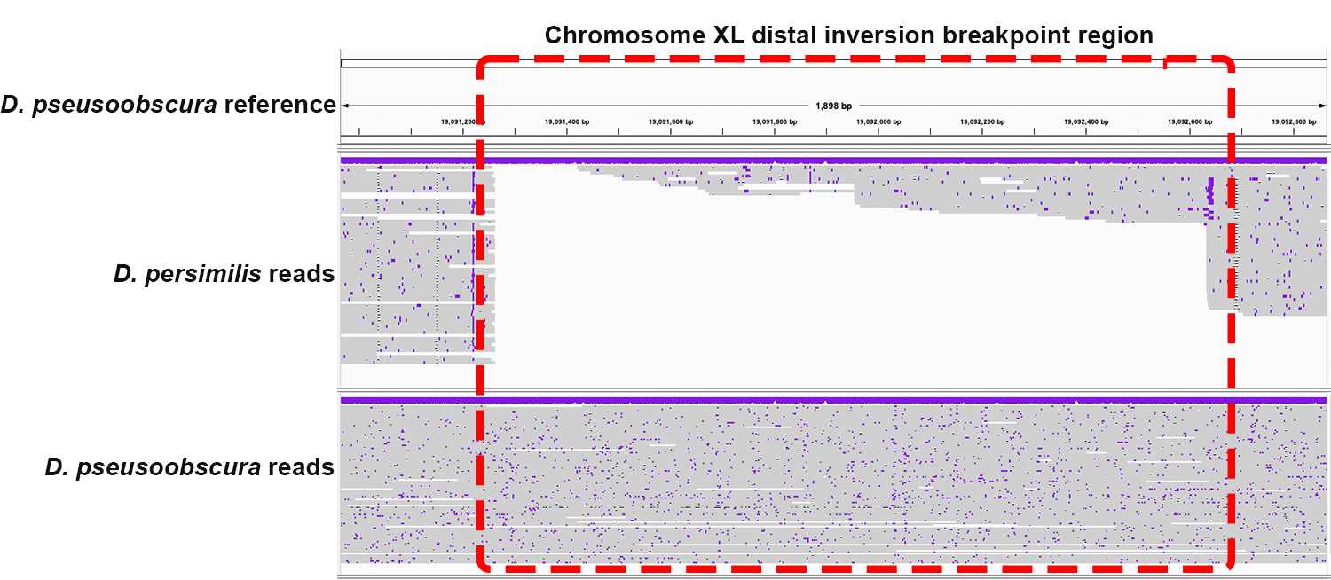

**Figure S24.**

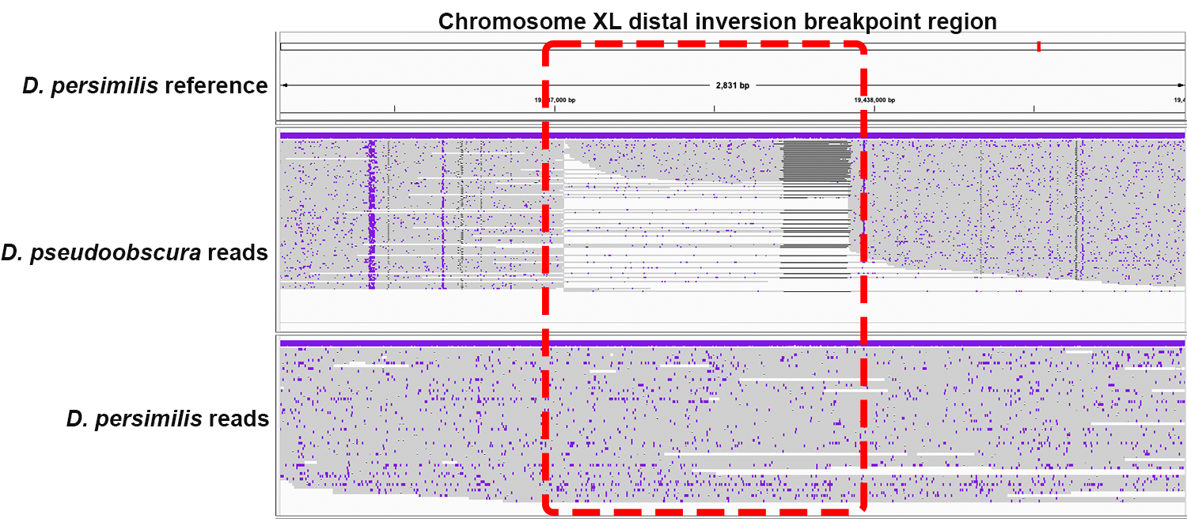

**Figure S25.**